Math 8 Application 10 Name ________________________
Show all your work!
1. Circle the letter that represents the approximate location on the number line of $\sqrt{110}$  A B C D  0 5 10 15 | 2. Write using a negative exponent:  $\frac{1}{25}$ = | 3. Solve for x:  x⁵ = 243
4. Write in standard notation.  5.48 ∙ 10⁸ | 5. Write the quotient in scientific notation.  (6.8 ∙ 10⁶) ÷ (2 ∙ 10⁵) = | 6. Solve for x.  -2x – 15 = -5x + 19
7. If the line segment below was translated up 3, left 4, name the coordinates of the endpoints.  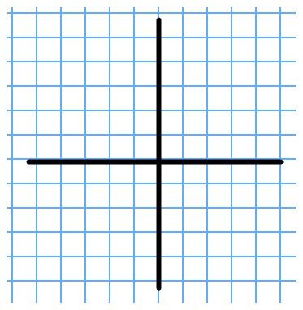 | 8. Find the length of side a below.  a 8 in.  5 in. | 9. Find the measure of angle b.  57◦  b
10. Put the following numbers in order from smallest to largest.  25%, 1/3, 1.3, 2.5 | 11. Estimate the difference below.  5,456,890 -- 978,945 | 12. Write the percent as a fraction in simplest form.  72 %
13. James is selling knives door to door. He had to buy a set of knives to use for demonstration for $75. He earns $20 for each set he sells. Write an equation for James function. | 14. Graph James function. | 15. Complete the table.
  Number of sets sold | James’ $
  0
  2
  5
  10
16. At Julie’s store, if she increases the price of her product by 50% in order to make a profit, what should she sell a product for that cost her $25? | 17. Find the volume of a can that has a diameter of 12 cm and a height of 20 cm. | 18. The record at the district meet for the 100 m run is 13.5 seconds. What is the rate of speed in meters per second?
19. Juan’s quiz scores are 7, 6, 9, 8, 10, 8, and 6. What is the median of his quizzes? | 20. If it is now 1:30 p.m., what time was is 4 hours and 40 minutes ago? | Number correct  5 minutes_______  Total___________

